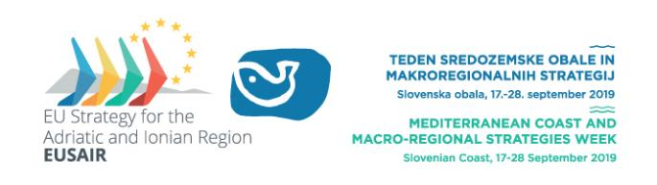
Mediterranean Coast and Macro-Regional Strategies Week 2019

LOGISTIC INFORMATION

Mediterranean Coast and EU Macro-regional Strategies Week will be held at different locations on Slovenian coast (Koper, Izola, Portorož) and in Poreč, Croatia. Purpose of this document is to help you arrange your travel and accommodation.
Logistic guidelines for the Slovenian coast:

KOPER, IZOLA, PORTOROŽ
From all nearby airports you can access Izola, Koper and Portorož with hotel transfer, bus or organized transfers, shuttles.
For accommodation we suggest you choose the city in which the majority of the events, that you wish to participate, will be held. There is not going to be specially organized transport between locations, because of the intercity bus line that connects coastal cities Koper, Izola and Portorož. Bus drives daily every 20 min from 5am to 10pm, max. distance between cities is 16 km.
Koper-Izola-Strunjan-Porotož-Piran: http://www.izola.info/avtobus.php?linija=2
Piran-Porotorž-Strunjan-Izola-Koper: http://www.izola.info/avtobus.php?linija=1

Local taxies contacts: Taxi1, 0038640 602 602, Taxi2, 0038641 706 777
Price of transfer from Koper to Izola and from Izola to Strunjan is 10,00 EUR, transfer from Koper to Strunjan is 15 EUR and from Koper to Portorož 20 EUR.

You can access all events location in Izola, Koper and Portorož by foot. In Koper and Izola all the events locations are within max. 10 min walk in Portorož there is only one event location.
Logistic guidelines for conference in Poreč:
In Poreč the event is held only in one location. From all nearby airports you can access Poreč by hotel transfer, bus or organized transfers, shuttles. Bus transfer to the conference’s second day event in Izola will be organized free of charge.

MORE ABOUT IZOLA

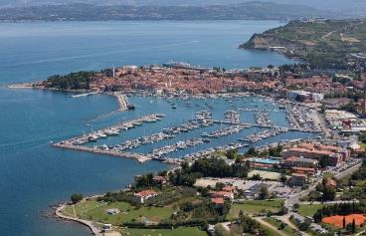

ACCOMODATION
- Hotel Marina***: http://www.hotelmarina.si/en/, info@hotelmarina.si , +386 5 66 04 100 (City centre of Izola).

- San Simon Hotel Resort:
Hotel Haliaetum****/annex Mirta**** and Annexes San Simon***,
https://www.hoteli-bernardin.si/en/accommodations/san-simon-resort, booking@h-bernardin.si , +386 5 690 7000 (5-10 min walk to the City centre)

MORE ABOUT KOPER

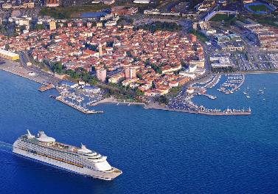

ACCOMODATION

- Garni Hotel Pristan**** http://www.pristan-koper.si/storitve/single/garni-hotel-pristan-1673; hotel@luka-kp.si; +386 5 614 40 00, (5- 10 min walk to City centre of Koper)
- Hotel Aquapark Žusterna*** https://www.terme-catez.si/si/obala/namestitve/aquapark-hotel-zusterna; info@terme-catez.si; tel:+386 20720493-6700, (5- 10 min walk to City centre of Koper)
- Hotel Vodišek**** http://www.hotel-vodisek.com/web/en/home/; info@hotel-vodisek.com; +386 5 639 24 68, (5- 10 min walk to City centre of Koper)

MORE ABOUT PORTOROŽ
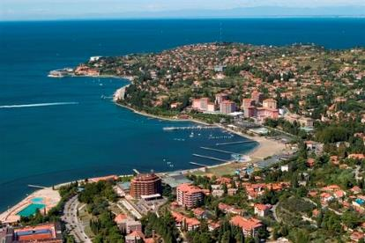

ACCOMODATION

- Hoteli Bernardin
Grand hotel Bernardin*****, Hotel Histrion****, Hotel Vile Park*** ; https://www.hoteli-bernardin.si/en/; booking@h-bernardin.si; +386 5 690 7000
- LifeClass Hotels & SPA Portorož
Line of hotels: Apollo****, Grand hotel Portorož****, Mind Hotel*****, Hotel Riviera****, Hotel Neptun****, Hotel Mirna****, https://www.lifeclass.net/en/; booking@lifeclass.net; +386 5 692 90 01; (10-15 min walk to venue at Hotel Bernardin)

MORE ABOUT STRUNJAN
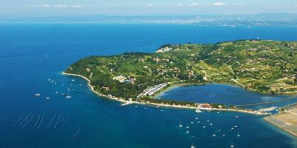

ACCOMODATION
- Terme Krka, Hotel Svoboda, Vile, Hotel Laguna, https://www.terme-krka.com/si/sl/destinacije/strunjan/+386 8 20 50 300, booking@terme-krka.si, (5 min walk to the bus station with the bus line to Izola, Koper and Portorož)
- Hotel Salinera****/***, https://www.hoteli-bernardin.si/si/namestitve/strunjan/hotel-salinera?gclid=EAIaIQobChMI8e_E7t-A3QIV06iaCh19jAoZEAAYASAAEgLTaPD_BwE, +386 80 11 19, booking@h-bernardin.si, (10 min walk to the bus station with the bus line to Izola, Koper and Porotorž)
- Hotel Oleander***, http://www.oleander.si/, INFO@OLEANDER.SI, +38656718100567 18, (5 min walk to the bus station with the bus line to Izola, Koper and Portorož)

MORE ABOUT POREČ
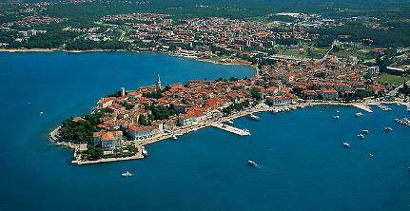

ACCOMODATION
- Hotel DIAMANT, Valmar ****/*** , https://www.valamar.com/en/hotels-porec/valamar-diamant-hotel ; +385 52 465 000, reservations@valamar.com
(Bus transfer from hotel to the conference’s second day location in Izola will be organized.)
- All additional info on Poreč iz available at https://www.myporec.com/en

LOGISTIC INFORMATION HOW TO REACH IZOLA, KOPER, STRUNJAN AND POROTOROŽ:

- BY AIR
You can travel to Slovenia by air to the central Jože Pučnik International Airport (Ljubljana Airport). Adria Airways is the only Slovenian air carrier and it operates most of the flights to Ljubljana.

From Jože Pučnik International Airport to Koper, Izola, Strunjan and Portorož

Shuttle service
At the airport there are different carriers at your disposal. Direct transfer from Jože Pučnik International Airport to Koper, Izola, Strunjan and Portorož are possible via a prior booking of destination at the shuttle service provider.
The most popular Shuttle service is GO-OPTI: https://www.goopti.com/en/

Rent-a-car
At the airport, rent a car at one of the rent-a-car providers.

Taxi
Taxis are available to you in front of the airport building
Telephone: ++386(0) 590 60 777
Mobile: ++386(0) 31 216 111 E-mail: taxiairport4@gmail.com
Website: http://airporttaxi.si/En/

Bus
At the Airport, you can take a bus to Ljubljana, there you have to switch to a domestic bus operating company.

From nearby airports to Slovenian coast
You can also fly to one of the nearby airports, and access Koper, Izola, Strunjan and Portorož from there by bus, train, shuttle service or rental car.
Trieste Airport (Friuli Venezia Giulia)
Venice Airport (Marco Polo)
Klagenfurt Airport
Graz Airport
Zagreb Airport (Franjo Tuđman Airport)
Pula Airport

- BY LAND
Car
If you choose to come to Slovenian coast by car, here are some useful tips on road use in Slovenia and what items you will need. Using car is the easiest way to travel around Slovenia.
The following speed limits apply on Slovenian roads:
- built-up/residential area 50 km/h
- regional roads 90 km/h
- express roads 110 km/h
- motorways 130 km/h

Vignettes
Motor cycles, private cars and vans whose maximum permitted weight does not exceed 3.5 tons must display a vignette to use on all Slovenian motorways and those express roads managed and maintained by the toll road operator. You can purchase vignettes at all petrol stations in Slovenia and in neighboring countries as well as at branches of national and foreign automobile clubs, at post offices in Slovenia and at some kiosks. List of sales points.

Vignette types
 | ONE-TRACK VEHICLES | TWO-TRACK  VEHICLES  CLASS 2A | TWO-TRACK VEHICLES  CLASS 2B
Weekly | 7,50 EUR | 15,00 EUR | 30,00 EUR
Monthly | – | 30,00 EUR | 60,00 EUR

Bus
Buses run to Slovenia from many European cities. If you choose to come to Slovenian coast by bus, please check the international bus transfers available at Ljubljana bus station.
In most cases international bus operating companies stops in Ljubljana, from there you have to switch to a domestic bus operating company. Direct international connections are also available:
From Trieste (Italy) to Koper and Izola, http://www.aptgorizia.it/ or http://www.autostazionetrieste.it/
From Ljubljana to Koper, Izola and Strunjan http://www.ap-ljubljana.si/
From Croatian Istria (Pula, Rovinj, Poreč, Umag) Info: http://www.autotrans.hr/
You can buy a bus ticket directly from the bus driver, while at major bus stops you can also buy a bus ticket for a specific date. Pay attention to choose the correct bus service provider when looking up timetables regarding departure and arrival times. Popular international bus operating companies are Flixbus, Autotrans, Arriva Express.
Train
Trains to Slovenia run daily from many European cities. If travelling by train, it is also possible to ride in a sleeping car. There are only the trains of Slovenian Railways running around Slovenia, with all the timetables and price lists published on the web pages. You can buy a ticket at every railway station as well as on the train. If you choose to come to Slovenian coast by train, plan your route here and here to the Koper railway station. From there you will have to take a local bus to Izola, Strunjan or Portorož.

LOGISTIC INFORMATION HOW TO REACH IZOLA, KOPER, STRUNJAN AND POROTOROŽ:

- BY AIR
You can travel to Slovenia by air to the central Jože Pučnik International Airport (Ljubljana Airport). Adria Airways is the only Slovenian air carrier and it operates most of the flights to Ljubljana.

From Jože Pučnik International Airport to Koper, Izola, Strunjan and Portorož

Shuttle service
At the airport there are different carriers at your disposal. Direct transfer from Jože Pučnik International Airport to Koper, Izola, Strunjan and Portorož are possible via a prior booking of destination at the shuttle service provider.
The most popular Shuttle service is GO-OPTI: https://www.goopti.com/en/

Rent-a-car
At the airport, rent a car at one of the rent-a-car providers.

Taxi
Taxis are available to you in front of the airport building
Telephone: ++386(0) 590 60 777
Mobile: ++386(0) 31 216 111 E-mail: taxiairport4@gmail.com
Website: http://airporttaxi.si/En/

Bus
At the Airport, you can take a bus to Ljubljana, there you have to switch to a domestic bus operating company.

From nearby airports to Slovenian coast
You can also fly to one of the nearby airports, and access Koper, Izola, Strunjan and Portorož from there by bus, train, shuttle service or rental car.
Trieste Airport (Friuli Venezia Giulia)
Venice Airport (Marco Polo)
Klagenfurt Airport
Graz Airport
Zagreb Airport (Franjo Tuđman Airport)
Pula Airport

LOGISTIC INFORMATION HOW TO REACH POREČ:

- BY LAND
Car
From the north: Ljubljana - Crni Kal - border crossing Pozane - Buzet - Vizinada - Porec or Ljubljana - Kopar - border crossing Kastel or Plovanija - Buje - Novigrad - Porec or Trst - Kopar - Kastel / Plovanija - Buje - Novigrad - Porec
From the east: Zagreb - Rijeka - Tunnel Ucka - Pazin - Baderna - Porec
From the south: Pula - Vodnjan - Bale - Sv.Lovrec - Porec

Road assistance
- from Croatia: (+385 1) 1987
- from abroad: +385 1 4693 700
- e-mail: 1987@hak.hr (Roadside assistance)
In case of car defect or accident, call HAK (Croatian Automobile Club) dispatcher centre tel. 1987 (round the clock). Services are paid in cash or credit cards. HAK is a member of AIT and FIA.
Traffic information and road conditions in Croatia
Daily news from HAK - Hrvatski Autoklub:
- e-mail: info@hak.hr (Traffic information)
www.hak.hr/en

Bus
Buses run to Croatia from many European cities. If you choose to come to Croatian coast by bus, please check the international bus transfers at https://www.buscroatia.com/bus-station-porec/ available at Poreč bus station.
In most cases international bus operating companies stops in Zagreb, from there you have to switch to a.

Bus station Poreč
Karla Huguesa 2, 52440 Poreč
Local, inter-city and international bus lines

International bus transfer companies:
Flixbus
Tel: +385 (0)1 300 08 03
podrska@flixbus.hr, service@flixbus.com
www.flixbus.com

Website for price comparison and online bus tickets purchase:
https://vollo.net/

Bus transfer search engine for Croatia & Europe:
www.busradar.hr

Train
If you are coming by regular passenger train, you can come from Ljubljana (SLO) via Divača (SLO) to Buzet (HR) or Pula (HR) which are located located only twenty to thirty kilometres away from Poreč. If you are coming on a regular train from Zagreb (HR) via Rijeka (HR), you will arrive in Pazin (HR), located only about 30 km away from Poreč.
Croatian Railways
Information on timetable (0-24): informacije@hzpp.hr
T. +385 (0)1 3782 583 calls from abroad
www.hzpp.hr

Rent-a-car
https://www.myporec.com/en/travel-planning/rent-a-car

- BY AIR
Poreč and Istria are attractive airplane destinations thanks to the vicinity of the Pula International Airport, located only about 50 km from Poreč. Many flight options offered by renowned airlines will get you to nearby airports quickly and safely.
Airport PULA
T: +385 52 530 105
F: +385 52 550 914
E-mail: informacije@airport-pula.hr
www.airport-pula.com
Airport LJUBLJANA (SI)
T: + 386 4 20 61 000
F: + 386 4 20 21 220
E-mail: info@lju-airport.si
www.lju-airport.si
Airport TRIESTE (RONCHI - Italy)
T: + 39 0481 773224
F: + 39 0481 474150
E-mail: info@aeroporto.fvg.it
www.aeroporto.fvg.it
Airport MARCO POLO (VENEZIA - Italy)
T: +39 (0)41 260 9260
E-mail: info@veniceairport.it
www.veniceairport.it

Airport RIJEKA
T: + 385 51 841 222
T: + 385 51 842 040
E-mail: information@rijeka-airport.hr
www.rijeka-airport.hr
Airport ZAGREB
T: + 385 1 456 22 22
Info: + 385 1 62 65 222
www.zagreb-airport.hr
Airport Transfers are available from

  - Airport bus Split
  - Airport bus Dubrovnik
  - Airport bus Pula
  - Airport bus Zadar
  - Airport bus Zagreb
  - Airport bus Rijeka-Krk
» Arrival planer: https://www.omio.com/
Taxi
https://www.myporec.com/en/travel-planning/taxi

- BY SEA
Ship lines:
Adriatic Lines
Sailing schedule: www.adriatic-lines.com
Venice - Umag-Umago / Poreč-Parenzo / Rovinj-Rovigno / Pula-Pola
Jadrolinija (Rijeka)
Sailing schedule: www.jadrolinija.hr
Porozina (Cres) - Brestova
Trieste Lines (Ustica Lines)
Sailing schedule: www.triestelines.it
Trst - Piran / Poreč-Parenzo / Rovinj-Rovigno / Pula-Pola
Venezia Lines
Sailing schedule: www.venezialines.com
Venice - Umag-Umago / Poreč / Rovinj-Rovigno / Pula
Catamaran Line
Pula - (Unije - Susak) - Mali Lošinj - (Ilovik – Silba) - Zadar
Sailing schedule: www.catamaran-line.hr
All additional info on Poreč iz available at https://www.myporec.com/en/travel-planning/transport
For any additional support regarding logistic and accommodation you can contact:
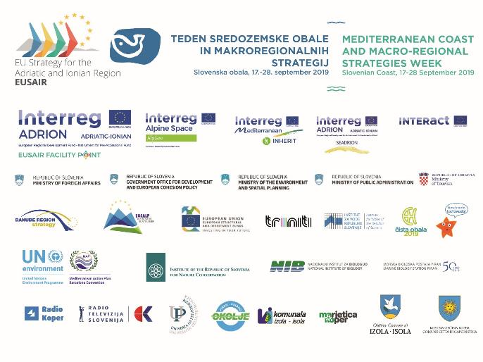
Municipality of Izola, project partner EUSAIR Facility Point, Implementing structure, Public agency for promotion of entrepreneurship and developing projects of Municipality of Izola, Sončno nabrežje 4, 6310 Izola, e: eusair@izola.si, t: +386 5 66 00 260

